Final Design

UML Class Diagram
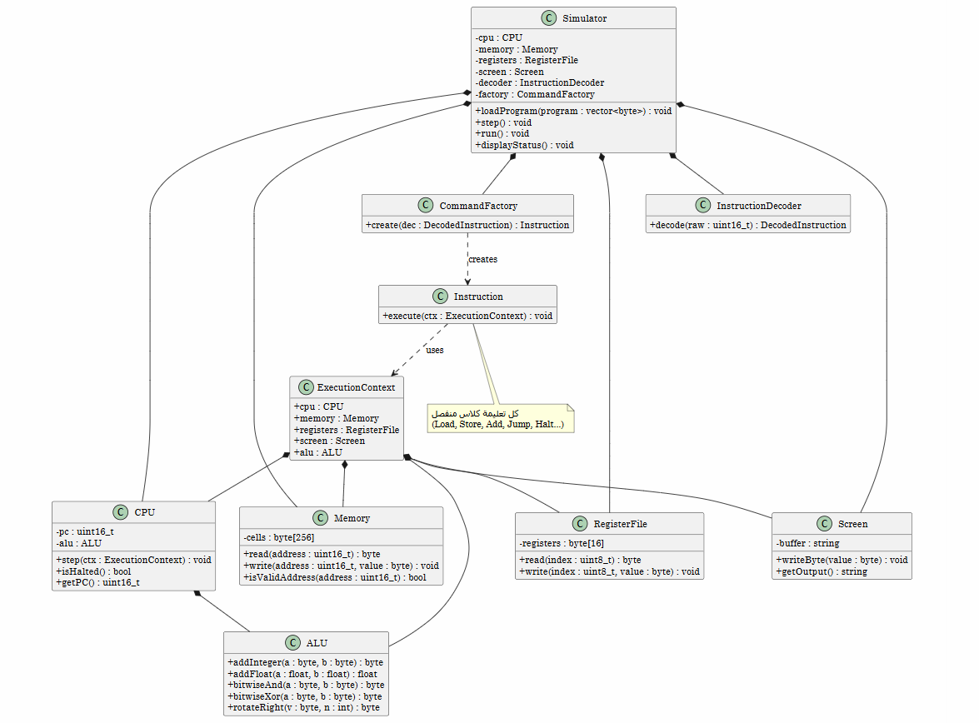

PlantUML Code
@startuml
skinparam classAttributeIconSize 0
skinparam packageStyle rectangle
hide empty members

class Simulator {
- cpu : CPU
- memory : Memory
- registers : RegisterFile
- screen : Screen
- decoder : InstructionDecoder
- factory : CommandFactory
+ loadProgram(program : vector<byte>) : void
+ step() : void
+ run() : void
+ displayStatus() : void
}

class CPU {
- pc : uint16_t
- alu : ALU
+ step(ctx : ExecutionContext) : void
+ isHalted() : bool
+ getPC() : uint16_t
}

class ALU {
+ addInteger(a : byte, b : byte) : byte
+ addFloat(a : float, b : float) : float
+ bitwiseAnd(a : byte, b : byte) : byte
+ bitwiseXor(a : byte, b : byte) : byte
+ rotateRight(v : byte, n : int) : byte
}

class Memory {
- cells : byte[256]
+ read(address : uint16_t) : byte
+ write(address : uint16_t, value : byte) : void
+ isValidAddress(address : uint16_t) : bool
}

class RegisterFile {
- registers : byte[16]
+ read(index : uint8_t) : byte
+ write(index : uint8_t, value : byte) : void
}

class Screen {
- buffer : string
+ writeByte(value : byte) : void
+ getOutput() : string
}

class InstructionDecoder {
+ decode(raw : uint16_t) : DecodedInstruction
}

class Instruction {
+ execute(ctx : ExecutionContext) : void
}

class CommandFactory {
+ create(dec : DecodedInstruction) : Instruction
}

class ExecutionContext {
+ cpu : CPU
+ memory : Memory
+ registers : RegisterFile
+ screen : Screen
+ alu : ALU
}

Simulator *-- CPU
Simulator *-- Memory
Simulator *-- RegisterFile
Simulator *-- Screen
Simulator *-- InstructionDecoder
Simulator *-- CommandFactory
CPU *-- ALU
CommandFactory ..> Instruction : creates
Instruction ..> ExecutionContext : uses

ExecutionContext *-- CPU
ExecutionContext *-- Memory
ExecutionContext *-- RegisterFile
ExecutionContext *-- Screen
ExecutionContext *-- ALU

note bottom of Instruction
كل تعليمة كلاس منفصل
(Load, Store, Add, Jump, Halt...)
end note

@enduml

